Construction Update
Coventry BF 0251(49)
Vermont Route 14 Bridge 132 Replacement

DATE: Friday, April 19, 2024

TRAFFIC IMPACT AND DURATION: From Monday, April 22, to Friday, April 26, during daytime hours, from 7:00 a.m. to 5:00 p.m., motorists should expect alternating one lane closures throughout the project limits.

CONSTRUCTION ACTIVITIES: Crews will continue fine grading the roadway, begin paving, and complete the guardrail installation.

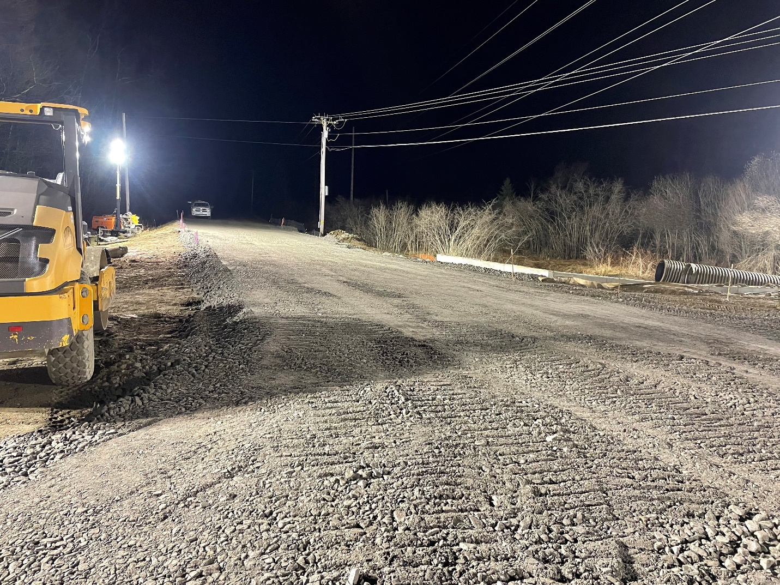

Photo of crews finishing the roadway surface in the evening of Sunday, April 14.

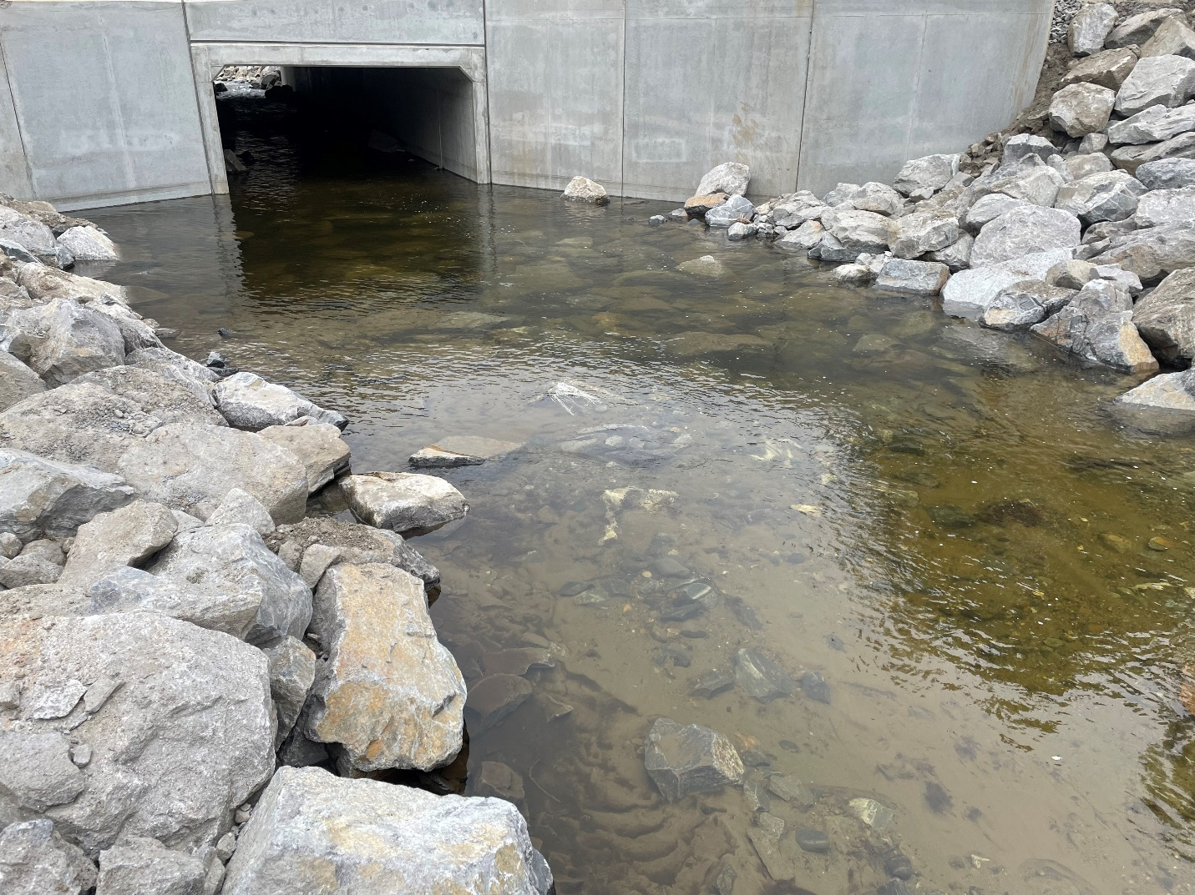
Photo of the outlet of the new box culvert.

LOCATION: Coventry BF 0251(49) is located on Vermont Route 14 over Stony Brook approximately 2.7 miles south of the junction with VT 100 in the Town of Coventry.

PROJECTED COMPLETION: Summer 2024

Contact Information:
Name – Sophia Schintzel
Phone – 781-400-8263
Email – sophia.schintzel@wsp.com

