Construction Update
Coventry BF 0251(49)
Vermont Route 14 Bridge 132 Replacement

DATE: Friday, April 12, 2024

TRAFFIC IMPACT AND DURATION: The 60-hour weekend bridge closure will begin today, Friday, April 12 at 6:00 p.m., and continue until Monday, April 15 at 6:00 a.m. Traffic will be maintained on an offsite detour during the closure.

PASSENGER VEHICLE DETOUR
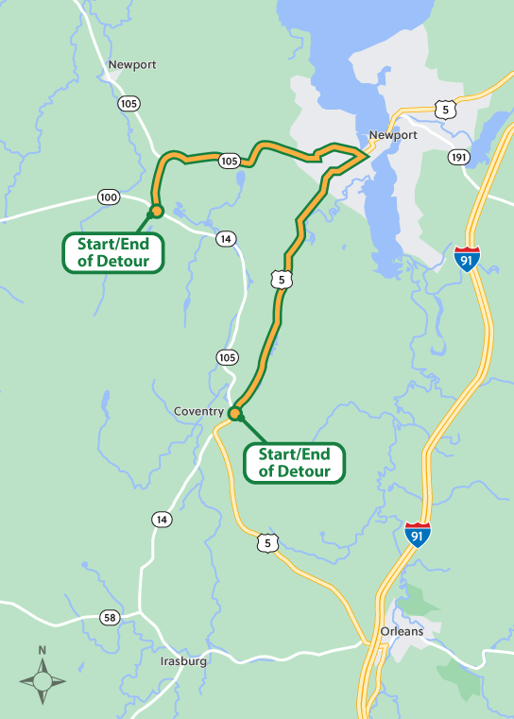

TRUCK DETOUR
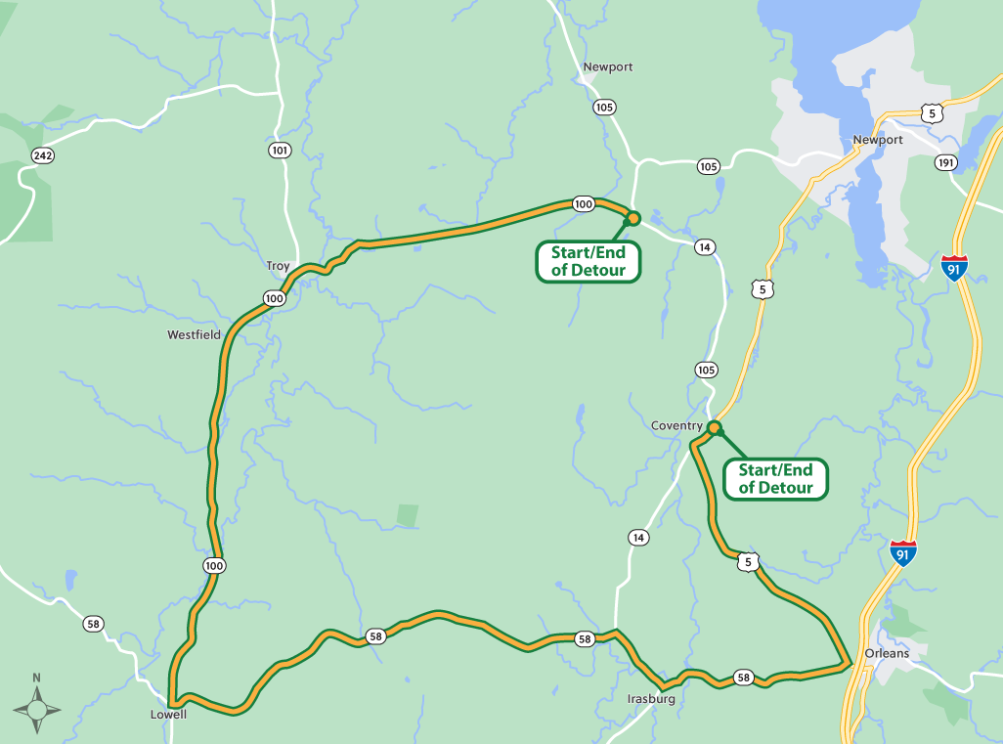

From Monday, April 12, to Friday, April 19, during daytime hours, motorists should except one lane closures throughout the project limits.

CONSTRUCTION ACTIVITIES: From Friday, April 12 to Monday, April 15, crews will replace the existing corrugated galvanized metal plate pipe arch with a precast concrete box.

From Monday, April 15, to Friday, April 19, crews will complete cold planing and guardrail work.

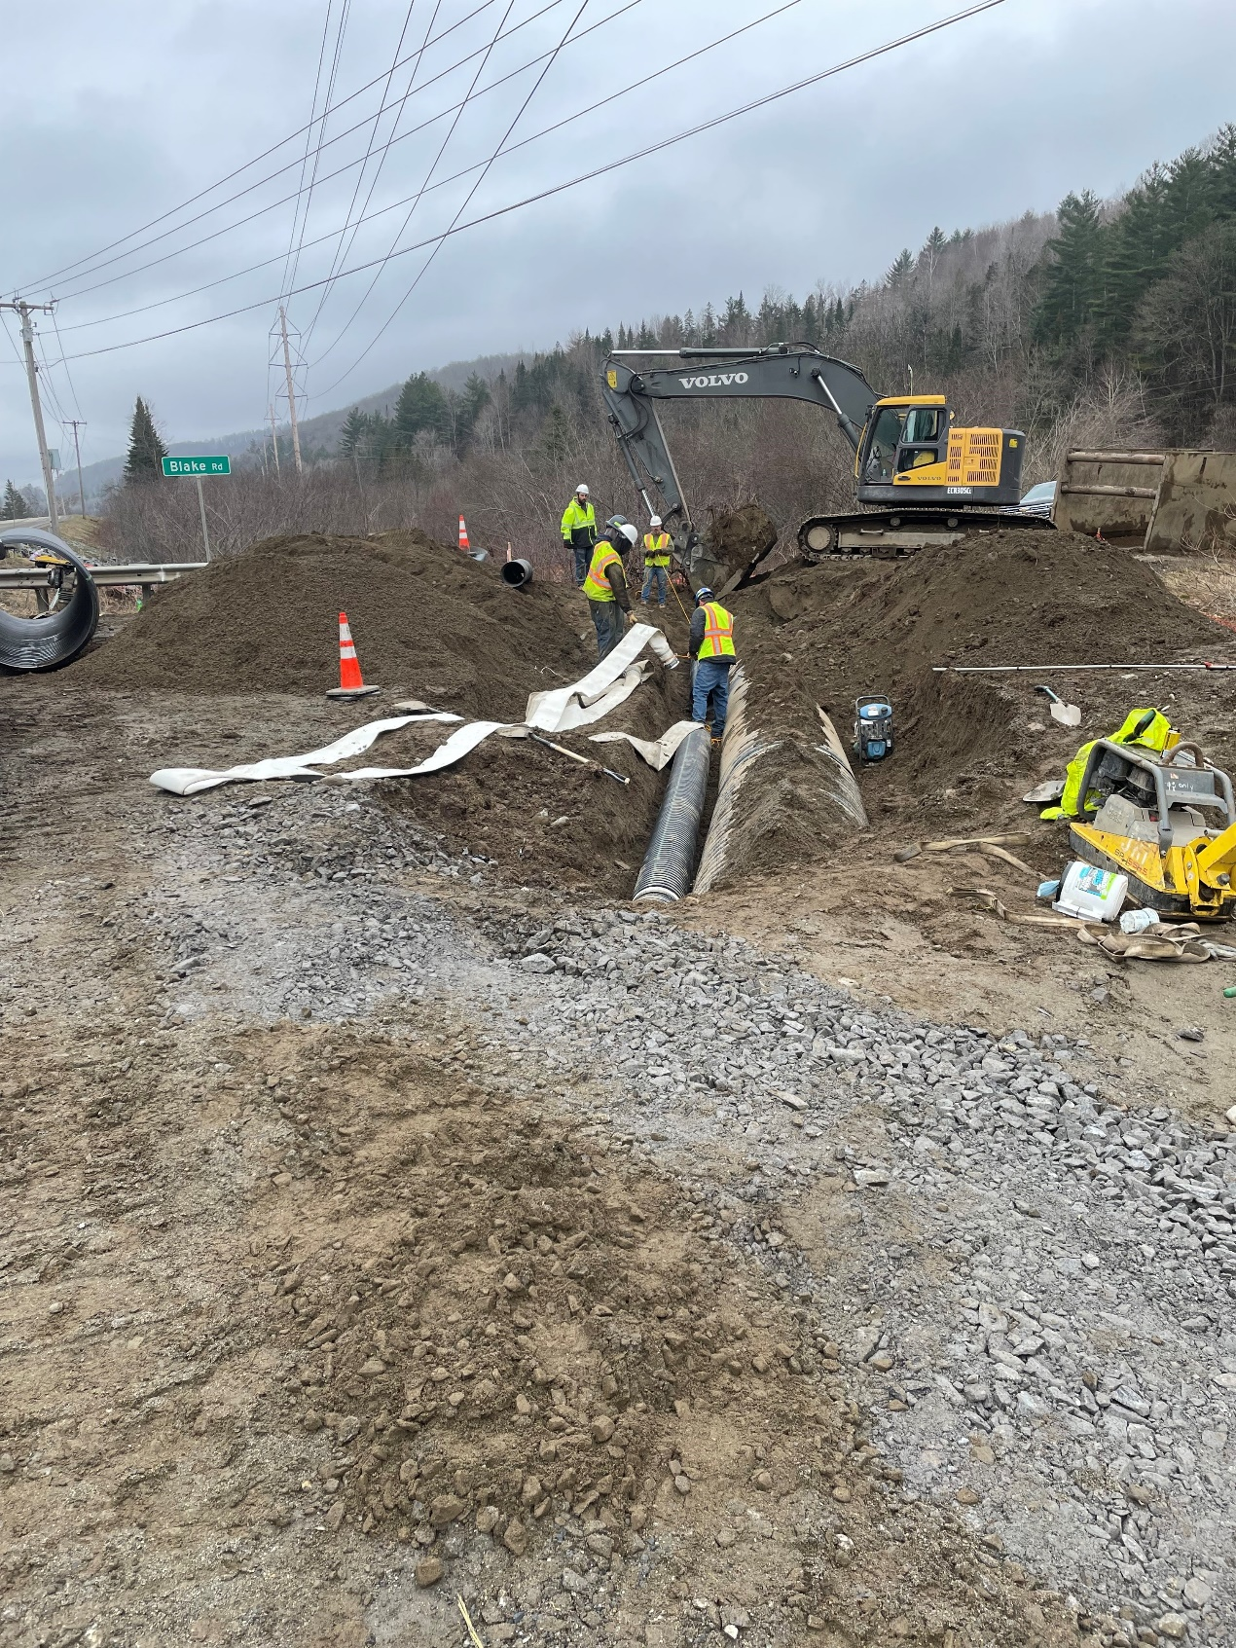
Photo of crews installing pipe for the steam diversion.

LOCATION: Coventry BF 0251(49) is located on Vermont Route 14 over Stony Brook approximately 2.7 miles south of the junction with VT 100 in the Town of Coventry.

PROJECTED COMPLETION: Summer 2024

Contact Information:
Name – Sophia Schintzel
Phone – 781-400-8263
Email – sophia.schintzel@wsp.com

